When children’s hands are moving, their minds are learning!
- Children learn best when their whole bodies are engaged in learning.
- Children need lots of active learning experiences to prepare for school.

Active learning advantages

Research* shows that signing is a powerful tool for active learning.

Second graders who had signed when they were babies scored an average of 12 points higher on IQ tests, suggestion that signing has a lasting impact on brain power.

*Signing with Babies and Children:
a comprehensive summary of the academic research on the impact of signing on cognitive, linguistic and social-emotional development
by Dr. Claire Vallotton

The best active learning tools include songs, signs and stories.
Why signs? They involve the whole body in learning, which helps children pay attention longer, so they learn more.
- Signs also help babies communicate before they can talk. Signing makes babies feel understood.
- Signs make it easier for preschoolers to learn letters and sounds, build vocabulary, and actively participate in story time. Signing makes learning more fun.

Active learning made easy
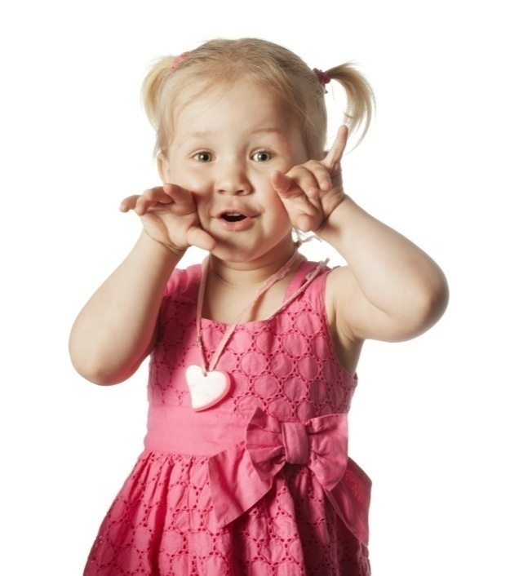
Now you can give your child the advantages of active learning with Sign to Learn. This program gives you award-winning songs, signs and stories that provide active learning experiences your child will love. With Sign to Learn products, you will see your child learn! Watch your child:
- sing and dance to songs with positive messages
- use signs to learn new words and concepts
- become actively engaged in learning colors,
numbers, letters – and social skills

Active learning with proven programs
Sign to Learn libraries include these award-winning products trusted by parents, backed by research and recommended by pediatricians. All Sign to Learn videos feature Rachel Coleman, Emmy-nominated host and co-creator of Signing Time!

Baby Signing Time
Selected by a university panel as one of the most effective early learning programs in the U.S., Baby Signing Time helps babies communicate before they can talk. This program reduces frustration and strengthens the parent-child bond. It helps sets your baby’s or toddler’s day to music, promoting language, learning, and fun.

Potty Time
This award-winning potty program helps children of any age sing, sign, and dance their way through potty training! The full program includes a video, music CD, book, timer watch, potty seat and plush. The free Potty Time app is the #1 potty training app for Apple and Android in the US.

Signing Time
Signing Time is a part of children’s television programming and is widely used by preschools across North America. Signing Time boosts vocabulary, early literacy skills, and social skills. Original songs are filled with positive messages that boost self-esteem.

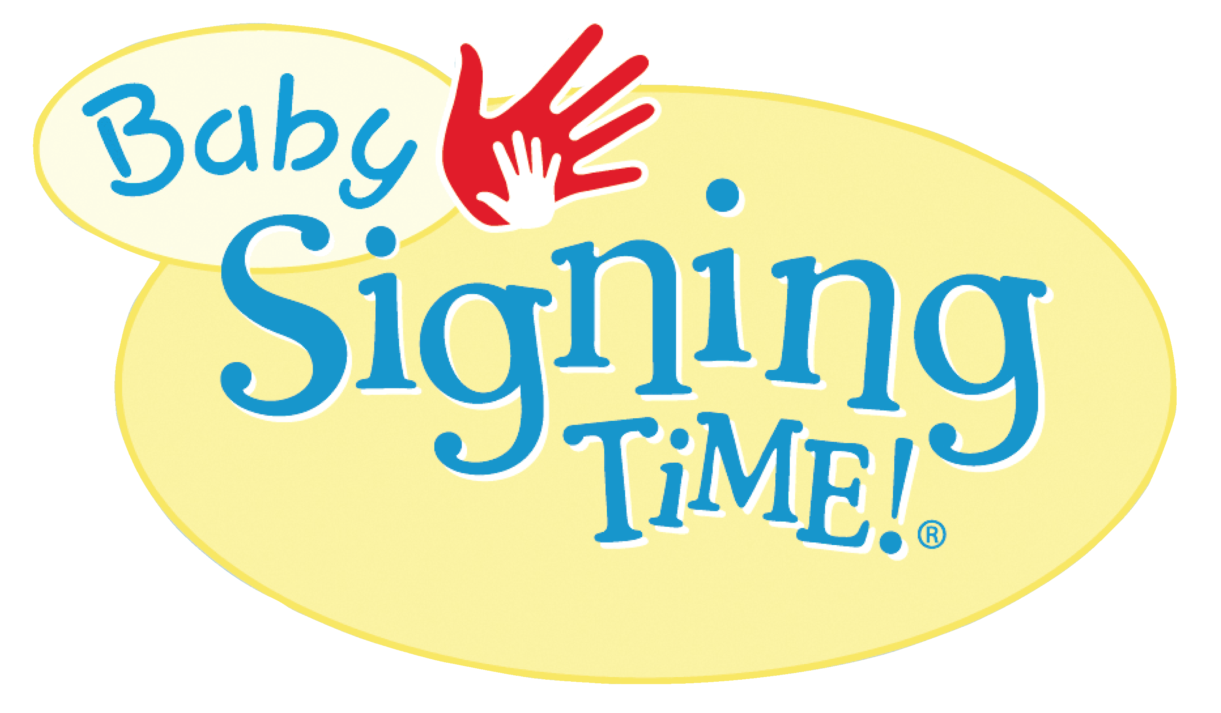

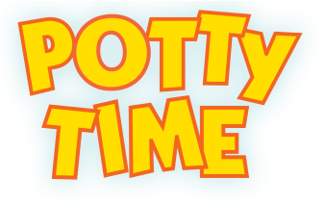

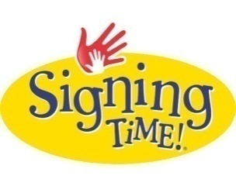

Signing Time educational videos are shown
on public television and Nick, Jr.

Extraordinary value
With Sign to Learn, you’ll receive
- a library of materials that will provide hours of active learning and fun for your child
- a monthly email filled with instant activities and free printables
- a qualified support representative who can answer your questions and provide enrichment ideas as your child moves through the program
Sign to Learn libraries carry our best-price guarantee. That means that you won’t find a better deal on these educational products anywhere else. You’ll save 50-60% off retail prices – a discount usually reserved for buyers like Costco and Wal-Mart! We’ve ditched the middle man and we’re passing the savings on to you and your family as well as the deserving teachers, schools and non-profit agencies dedicated to serving young children.

Enroll in our convenient monthly delivery program or choose a “Buy Now” library for even greater savings. Choose the library that best fits your child’s needs – and your budget!
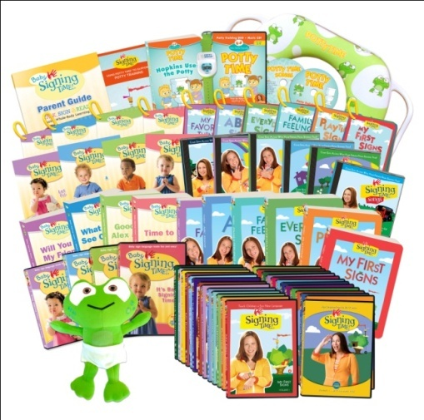

Complete Library
Our entire active learning library!
Get everything you need: videos, song CDs, books, flash cards, guides, Hopkins plush and more.

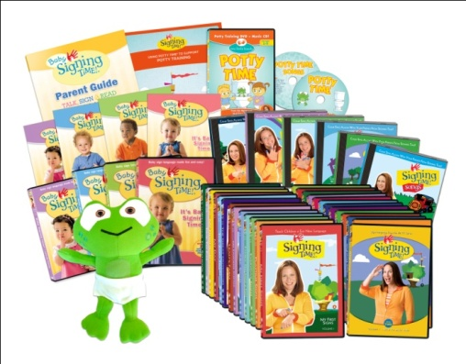
Plus Library
This library includes all of the videos and song CDs from the Complete Library, plus posters, guides, and a Hopkins plush.

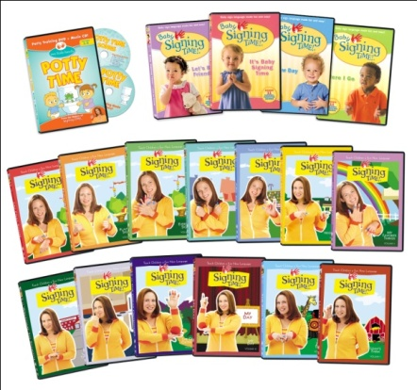
Basic Library
This library has all of the award-winning Baby Signing Time, Potty Time and Signing Time videos.

Best Price Guaranteed
Satisfaction Guaranteed
Easy Cancel Any Time

Complete Library
Ideal for families and teachers. Get the entire learning library and give your children the full advantages of active learning. Includes a full potty training program! The retail value of this library exceeds $1,500. Get 4-5 items in each monthly delivery, or get it all at once with the Buy Now option.
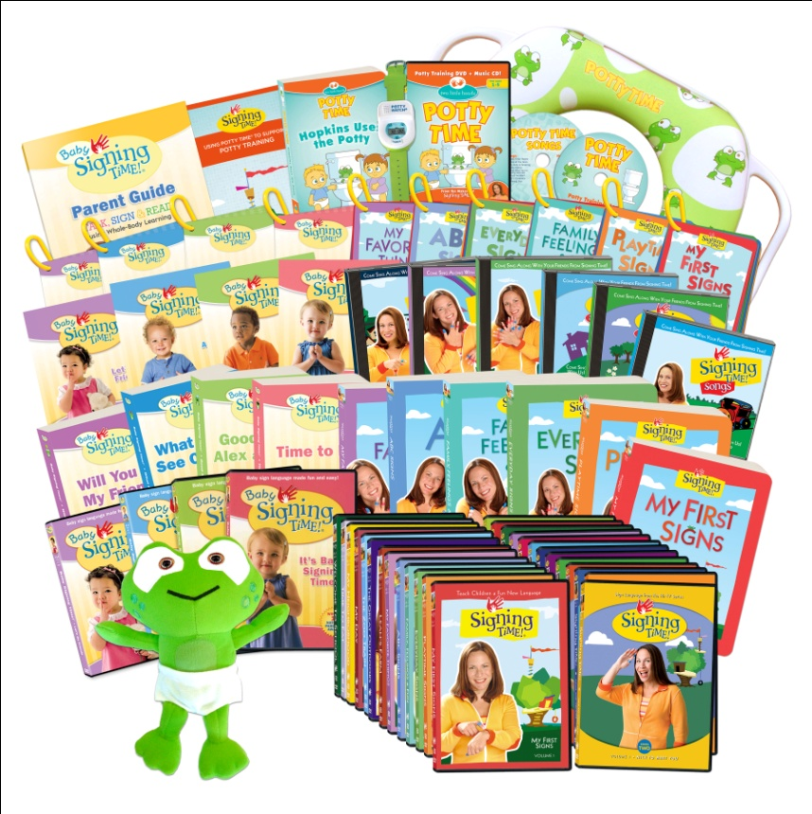
Library Contents
31 Educational Videos
11 Original Song CDs
11 Sturdy Board Books
10 Colorful Flash Card Sets
4 Sign Reference Posters
1 Potty Training Guide
1 Baby Hopkins Plush
1 Hopkins Potty Seat
1 Potty Time Watch
1 Parent Guide
Plus the Complete Digital Library,
a $499 retail value!

Plus Library
Videos and CDs - plus more! Get award-winning songs, signs and stories with this active learning media library. Get 2-3 items in each monthly delivery, or get it all at once with the Buy Now option.
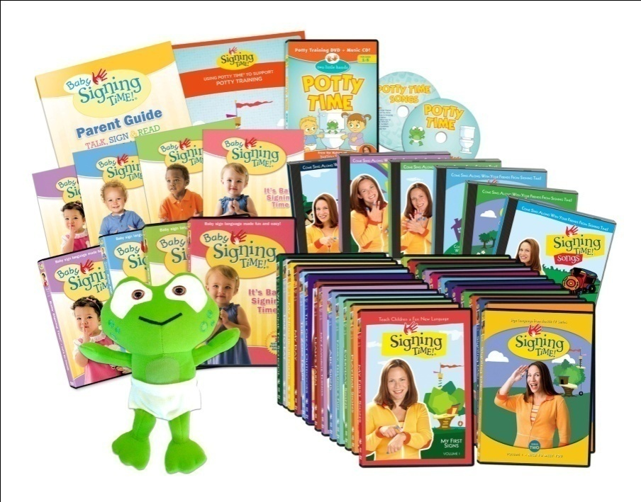
Library Contents
31 Educational Videos
11 Original Song CDs
4 Sign Reference Posters
1 Potty Training Guide
1 Baby Hopkins Plush
1 Parent Guide

Basic Library
Video Starter Set! Get started with this essential active learning video library with Emmy-nominated host Rachel Coleman. Get one educational video each month, or get them all at once with the Buy Now option.

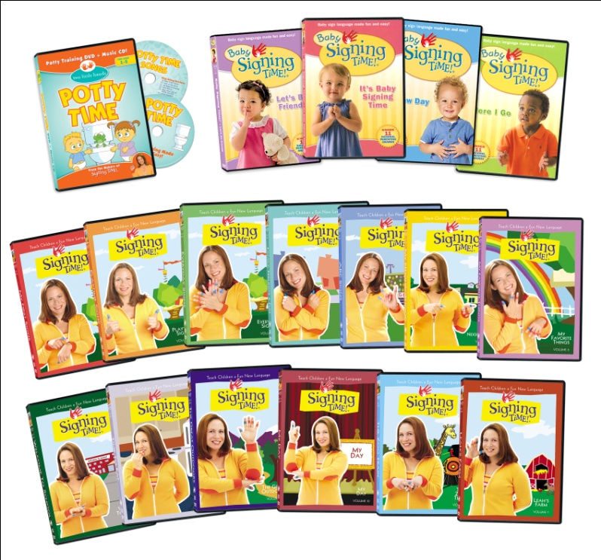
Library Contents
1 Potty Time Video + Music CD
4 Baby Signing Time Videos
13 Signing Time Videos

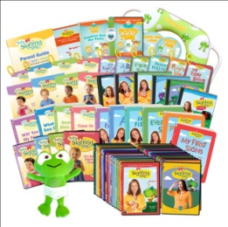
Complete Library

Monthly  Delivery | Library Items
1 | Baby Signing Time Vol. 1 DVD: It’s Baby Signing Time  Music CD, Poster, Board Book, Flash Card Set, Parent Guide
2 | Baby Signing Time Vol. 2 DVD: Here I Go  Music CD, Poster, Board Book, Flash Card Set
3 | Baby Signing Time Vol. 3 DVD: A New Day  Music CD, Poster, Board Book, Flash Card Set
4 | Baby Signing Time Vol. 4 DVD: Let’s Be Friends  Music CD, Poster, Board Book, Flash Card Set
5 | Potty Time DVD, Music CD, Board Book, Hopkins Plush,  Potty Time Reminder Watch, Cushioned Potty Seat
6 | Signing Time My First Signs DVD, Nice to Meet You DVD  Music CD, Board Book 1, Flash Card Set 1
7 | Signing Time Playtime Signs DVD, Happy Birthday DVD  Board Book 2, Flash Card Set 2
8 | Signing Time Everyday Signs DVD, Move and Groove DVD  Board Book 3, Flash Card Set 3
9 | Signing Time Family, Feelings and Fun DVD, My Favorite  Season DVD, Music CD, Board Book 4, Flash Card Set 4
10 | Signing Time ABC Signs DVD, Going Outside DVD  Board Book 5, Flash Card Set 5
11 | Signing Time My Favorite Things DVD, Days of the Week DVD  Board Book 6, Flash Card Set 6
12 | Signing Time Leah’s Farm DVD, The Great Outdoors DVD  My Favorite Sport DVD, My House DVD, Music CD
13 | Signing Time The Zoo Train DVD, My Day DVD, My Things DVD  Helping Out Around the House DVD, Music CD
14 | Signing Time My Neighborhood DVD, Time to Eat DVD  Once Upon a Time DVD, Music CD
15 | Signing Time Welcome to School DVD, Box of Crayons DVD, Who Has the Frog DVD, Music CD, Complete Digital Library – a $499 value!
This library is delivered in 15 shipments.
Signing Time Only customers receive Deliveries 6-15 for a total of 10 shipments.

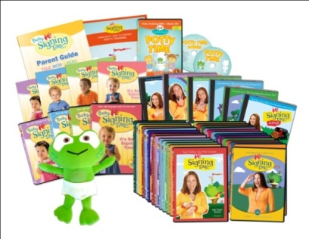
Plus Library
Monthly Delivery |  | Library Items
 | 1 | Baby Signing Time  Vol. 1 DVD: It’s Baby Signing Time, Music CD, Poster, Parent Guide
 | 2 | Baby Signing Time  Vol. 2 DVD: Here I Go, Music CD, Poster
 | 3 | Baby Signing Time  Vol. 3 DVD: A New Day, Music CD, Poster  This library is delivered in 17 shipments.  Signing Time Only customers receive Deliveries 6-17 for a total of 12 shipments.
 | 4 | Baby Signing Time  Vol. 4 DVD: Let’s Be Friends, Music CD, Poster
 | 5 | Potty Time  Potty Time DVD, Music CD, Hopkins Plush
 | 6 | Signing Time  My First Signs DVD, Nice to Meet You DVD, Music CD
 | 7 | Signing Time  Playtime Signs DVD, Happy Birthday DVD
 | 8 | Signing Time  Everyday Signs DVD, Move and Groove DVD
 | 9 | Signing Time  Family, Feelings and Fun DVD, My Favorite Season DVD, Music CD
 | 10 | Signing Time  ABC Signs DVD, Going Outside DVD
 | 11 | Signing Time  My Favorite Things DVD, Days of the Week DVD
 | 12 | Signing Time  Leah’s Farm DVD, My Favorite Sport DVD, Music CD
 | 13 | Signing Time  The Great Outdoors DVD, My House DVD
 | 14 | Signing Time  The Zoo Train DVD, My Things DVD, Music CD
 | 15 | Signing Time  Helping Out Around the House DVD, My Day DVD
 | 16 | Signing Time  My Neighborhood DVD, Once Upon a Time DVD
 | 17 | Signing Time  Time to Eat DVD, Box of Crayons DVD, Welcome to School DVD, Who has the Frog DVD, 2 Music CDs – a $100 retail value delivery!

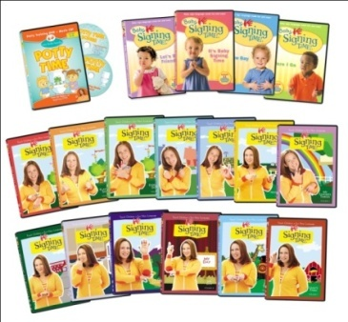
Monthly Deliveries: Basic Library
Delivery | Library Items
1 | Baby Signing Time  Vol. 1 DVD: It’s Baby Signing Time
2 | Baby Signing Time  Vol. 2 DVD: Here I Go
3 | Baby Signing Time  Vol. 3 DVD: A New Day  This library is delivered in 17 shipments.  Signing Time Only customers receive Deliveries 6-17 for a total of 12 shipments.
4 | Baby Signing Time  Vol. 4 DVD: Let’s Be Friends
5 | Potty Time  Potty Time DVD
6 | Signing Time  My First Signs DVD
7 | Signing Time  Playtime Signs DVD
8 | Signing Time  Everyday Signs DVD
9 | Signing Time  Family, Feelings and Fun DVD
10 | Signing Time  ABC Signs DVD
11 | Signing Time  My Favorite Things DVD
12 | Signing Time  Leah’s Farm DVD
13 | Signing Time  The Great Outdoors DVD
14 | Signing Time  The Zoo Train DVD
15 | Signing Time  My Day DVD
16 | Signing Time  My Neighborhood DVD
17 | Signing Time  Time to Eat DVD, Welcome to School  DVD – a $40 retail value delivery!

Buy Now Options

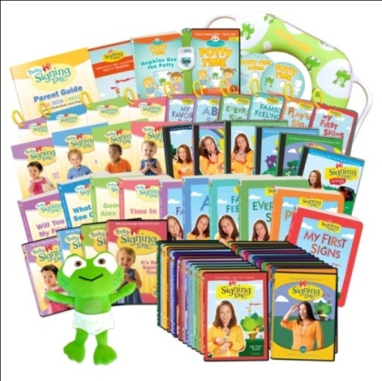
Complete Library
FULL PROGRAM: $549.99
free shipping + complete digital library
SIGNING TIME ONLY: $399.99
free shipping, no digital library

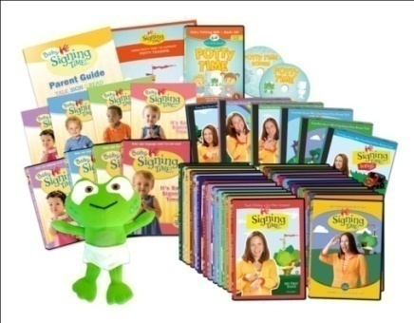
Plus Library
FULL PROGRAM: $299.99
free shipping
SIGNING TIME ONLY: $199.99
free shipping

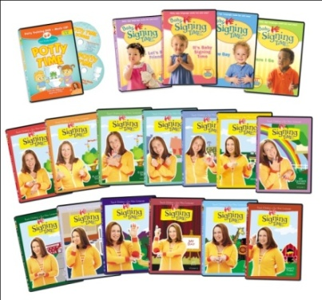
Basic Library
FULL PROGRAM: $149.99
free shipping
SIGNING TIME SERIES 1 DVD SET: $99.99
SIGNING TIME SERIES 2 DVD SET: $99.99
free shipping on both sets

